3 December 2023

Col Cooper, members of the Aeronautics Permanent Professor selection committee,
Thank you for the opportunity to apply to be USAFA’s Permanent Professor of Aeronautics. I believe I have the skills, experience, and passion necessary to lead the Department of Aeronautics to continued excellence in pursuit of the Air Force Academy’s mission to educate, train, and inspire Air Force and Space Force officers.
My passion is cultivating apperception–the spark when a student moves from knowledge to understanding. As an educator, I promote intellectual development through hands-on learning and developing complex systems. As a leader, I promote development of junior officers through delegation of real responsibility and intentional mentoring through complex situations. Creating an environment where cadets and officers develop as engineers and leaders is the primary job of the Permanent Professor of Aeronautics. I will thrive in that role.
I have extensive experience with undergraduate education—mostly Astronautics at the Air Force Academy, but also Engr Mech 320 and Sophomore-level ROTC at NC State. During eight semesters in the Department of Astronautics, I have been course director for core Astro and two majors’ classes. I also run the Astro Department’s assessment program, ensuring we stay on track for successful accreditation at our next ABET visit.
My current primary course responsibility is Astro Engr 331: Space Systems Engineering. I have rewritten the curriculum over three semesters to cover topics relevant to modern space systems. I also developed completely new hands-on projects for the lab-based course, including development of an Arduino-based spacecraft analog. In addition to subsystem performance, the course now includes a heavy emphasis on experimentation, including instrumentation, analysis, and reporting. The experimental nature of this class has proven effective at instilling understanding, and several cadets have expressed pride after successfully completing a final complex project on their own.
My research specialty is integration of complex systems, including the testing necessary to prove their effectiveness and safety. In addition to thorough system-level understanding, this work requires careful administration, documentation, and collaboration—characteristics I strive to instill in cadet research. During my PhD research, I developed a spacecraft boom deployment mechanism. My flight test background was crucial for winning a NASA flight opportunity grant and leading a 14-member team to safe and successful execution of a Zero-G flight test campaign demonstrating boom deployment.
At the Air Force Academy, I have led multiple cadet research projects. One current research focus is in-house development of spacecraft reaction wheels. For two years, I have led cadets in manufacturing, integrating, and testing wheels to eliminate unwanted vibration and ensure launch survivability. For complete scholarship, I also guide cadets through publication of conference papers describing their work. It is a joy to see knowledge turn to understanding through this work.
My most rewarding assignment to date has been a Defense Intelligence Agency tour in Charlottesville VA. While there, I gained an appreciation for joint warfare and developed strong leadership skills. I briefly led an Air Analysis team, monitoring emerging threats to US air systems. Later as a branch chief, I led a team of 29 analysts from all domains, including a mix of junior employees and recognized experts—a composition similar to the Department of Aeronautics. Most importantly, I developed branch personnel into future leaders. My success was watching newly empowered officers lead teams and develop a thriving office culture.
The Department of Aeronautics has a long history of excellent hands-on education in core and majors’ classes alike. I have fond memories of Dr. Brandt’s Aero class which was vital to my effectiveness as an Air Force officer and engineer. A key experience was the terrazzo tour to demonstrate how constraints affect airframe design. I also enjoyed the balsa glider project, and am now pleased to see hundreds of gliders in the halls near the end of each semester.
The Permanent Professor of Aeronautics provides organizational stability and promotes Aeronautics within the Academy and beyond. Important Departmental relationships beyond DF include the Athletic Department to support student athletes who embrace a challenging major, the Airfield to execute the flagship Aero 456: Flight Test Techniques, as well as the organizations who employ the bulk of Aeronautical Engineering Majors: Air Education and Training Command, Air Force Materiel Command, and Test Pilot School. My Academy assignments and Air Force test background gives me a solid foundation for building and maintaining relationships in all of these areas.
In addition to the enduring challenge of training cadets and developing young officers, the Department of Aeronautics must continually adapt to changes in aeronautics and education. Current trends include advances in hypersonics, ubiquitous stealth, and autonomous systems, all driven by advances in computing power. Computing advances also create new possibilities in engineering education. The Department must judiciously adapt its curriculum to maintain relevance within the constraints of a demanding four-year cadet education. These challenges completely align with my strengths and interests, and I would be delighted to guide the Department’s evolution as Permanent Professor and Head of the Department of Aeronautics.
My career has moved fluidly between air and space. The disciplines complement each other; practice in one makes me better at the other. I love each domain and have extensive experience in both, including flight test experience in an Air Force flight test unit and as part of my PhD research.
As a Space Force officer, I bring an inherently joint perspective to Aeronautics. I also bring significant personal experience with many aspects of Aeronautical Engineering, including flight test, hands-on research, and systems engineering. I have guided curriculum delivery and development as an instructor and course director, and as Director of Assessment. I have a passion to develop leaders at every level, and I want to build and maintain a vibrant culture of excellence within the Department of Aeronautics.
The Department of Aeronautics will continue developing Air Force and Space Force officers for decades to come. If selected as the Permanent Professor of Aeronautics it will be an absolute joy to lead the department as they do.
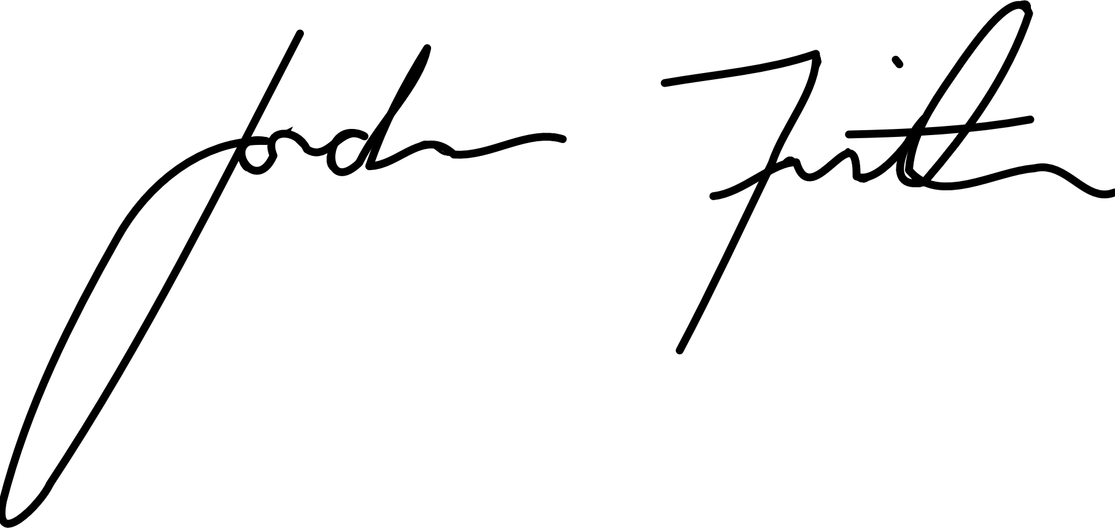
Respectfully,

Jordan Firth, Lt Col, USSF
Assistant Professor
USAFA Department of Astronautics

